**LESSON NOTES FOR P.4 SCIENCE TERM III**

**THEME: HUMAN HEALTH**

**SUB –THEME: COMMUNICABLE DISEASE AND WORM INFESTATIONS**

**CONTENT: COMMUNICABLE DISEASES**

**Vocabulary**

* Diarrhea
* Dysentery
* Typhoid
* Infected
* Diseases
* Faecal
* Communicable

**WHAT ARE COMMUNICABLE DISEASES?**

These are diseases that are spread from an *infected* person to a healthy one.

**Examples of communicable diseases**

* diarrhoea
* dysentery
* cholera
* typhoid
* ebola
* polio
* tetanus
* measles
* tuberculosis

**Communicable intestinal diseases**

These are diseases that attack the intestines and spread from a sick person to another.

**Examples of communicable intestinal diseases**

* typhoid
* cholera
* diarrhea
* dysentery

**Non- communicable diseases**

These are diseases that do not spread from a sick person to a healthy one.

**Examples of non communicable diseases**

* cancer
* kwashiorkor
* marasmus
* night blindness

**Causes of intestinal common communicable diseases**

Dysentery – bacteria

Cholera – bacteria

Typhoid – bacteria

Diarrhoea – virus or bacteria

**How these diseases are spread**

They are spread through the 4F’s i.e.

* Faeces
* Flies
* Food
* Fingers
* Through drinking un boiled water
* Eating contaminated food.
* Body contact with an infected person

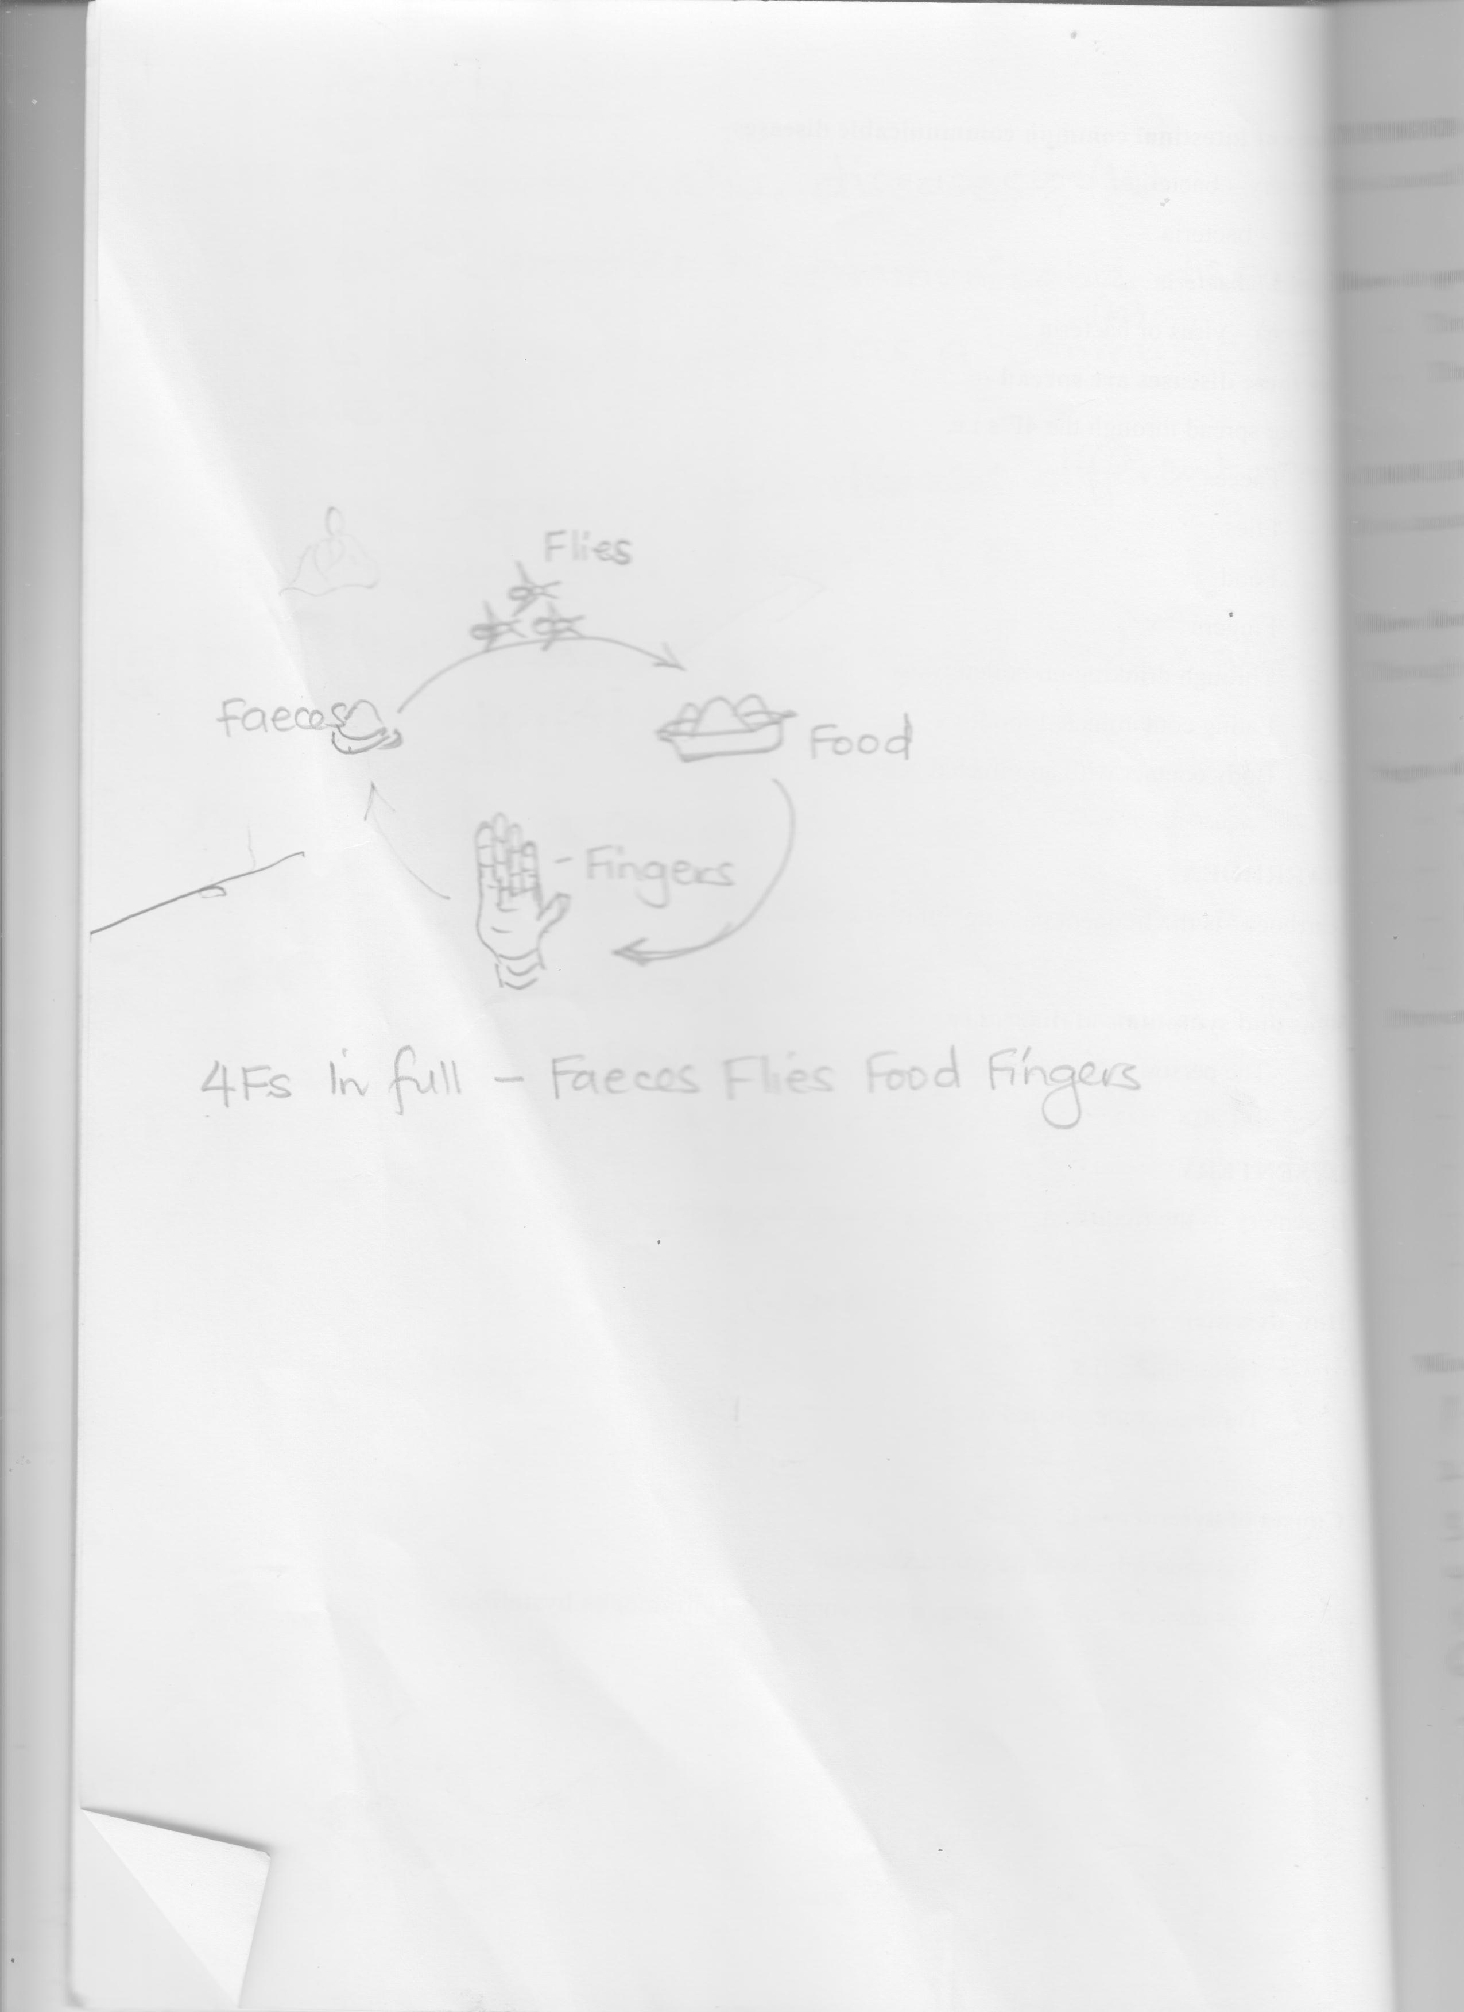

**4Fs in full –** Faeces Flies Food Fingers

**Activity**

1. What are communicable diseases?
2. Give two examples of communicable diseases
3. Why is cholera regarded as a communicable disease?
4. How are communicable diseases different from non communicable diseases?
5. State the reason why we should boil water for drinking.
6. Why should a person with diarrhea pass out much watery stool?
7. Apart from cholera, name one other intestinal communicable disease.
8. Why should you not shake hands with a person having diarrhea?
9. Why should we cover our food?
10. Apart from bacteria, name any other cause of diarrhea.

**DIARRHOEA**

Diarrhoea is the frequent passing out of watery stool.

**Signs and symptoms of diarrhoea**

* The person passes out watery stool.

**DYSENTERY**

Dysentery is the frequent passing out of watery stool with blood stains.

**How dysentery spreads**

* Through the 4Fs
* Through contaminated water

**Causes of dysentery**

* It is caused by bacteria called **shigella**
* It is also caused by amoebas n the group called **entamoeba** **hystolitica**.

**TYPHOID**

**Vocabulary**

* Salmonella
* Typhi
* Contaminated
* Severe
* Vomiting
* Headache
* Stomachache
* Defecation
* Faeces

It is caused by bacteria called Salmonella typhi

**How it spreads**

* Through the 4Fs
* Through contaminated food and water

**CHOLERA**

It is caused by bacteria called Vibrio cholerae

**How does cholera spread?**

Through contaminated food or water

**Signs of cholera**

* Serious diarrhea
* Vomiting
* Dehydration
* Weakness

**Prevention and control of Diarrhoeal diseases**

* Proper disposal of faeces
* Boiling drinking water
* Covering cooked food
* Re-heating leftover food
* Washing hands after visiting the latrine

**Mixed activity**

1. Give the meaning of communicable diseases.
2. Apart from typhoid, mention any other two examples of communicable diseases.
3. Write the 4Fs in full
4. Which vector is a major carrier of germs in the 4Fs?
5. Why are houseflies able to spread diseases?
6. How can a mother protect her baby from kwashiorkor?
7. Why should we wash fresh fruits before eating?
8. State the importance of root hairs to a maize plant.

**Practical**

**DEHYDRATION**

**Vocabulary**

* Dehydration
* Severe
* Rehydration
* Diarrhea
* Severe
* Sunken
* Soft sport
* Fontanelle

**DEHYDRATION**

Dehydration is a condition when the body does not have enough water in it.

**Causes of dehydration**

* Severe diarrhea
* Severe vomiting

**Signs of dehydration**

* Sunken eyes
* Dry mouth / lips
* The person passes out little or no urine
* Sunken fontanelle in babies
* Get an empty mineral water bottle.
* Cut it at the top and tie it with a polythene.
* Fill the cut bottle with water and drill some small holes at the bottom and sides to let out water

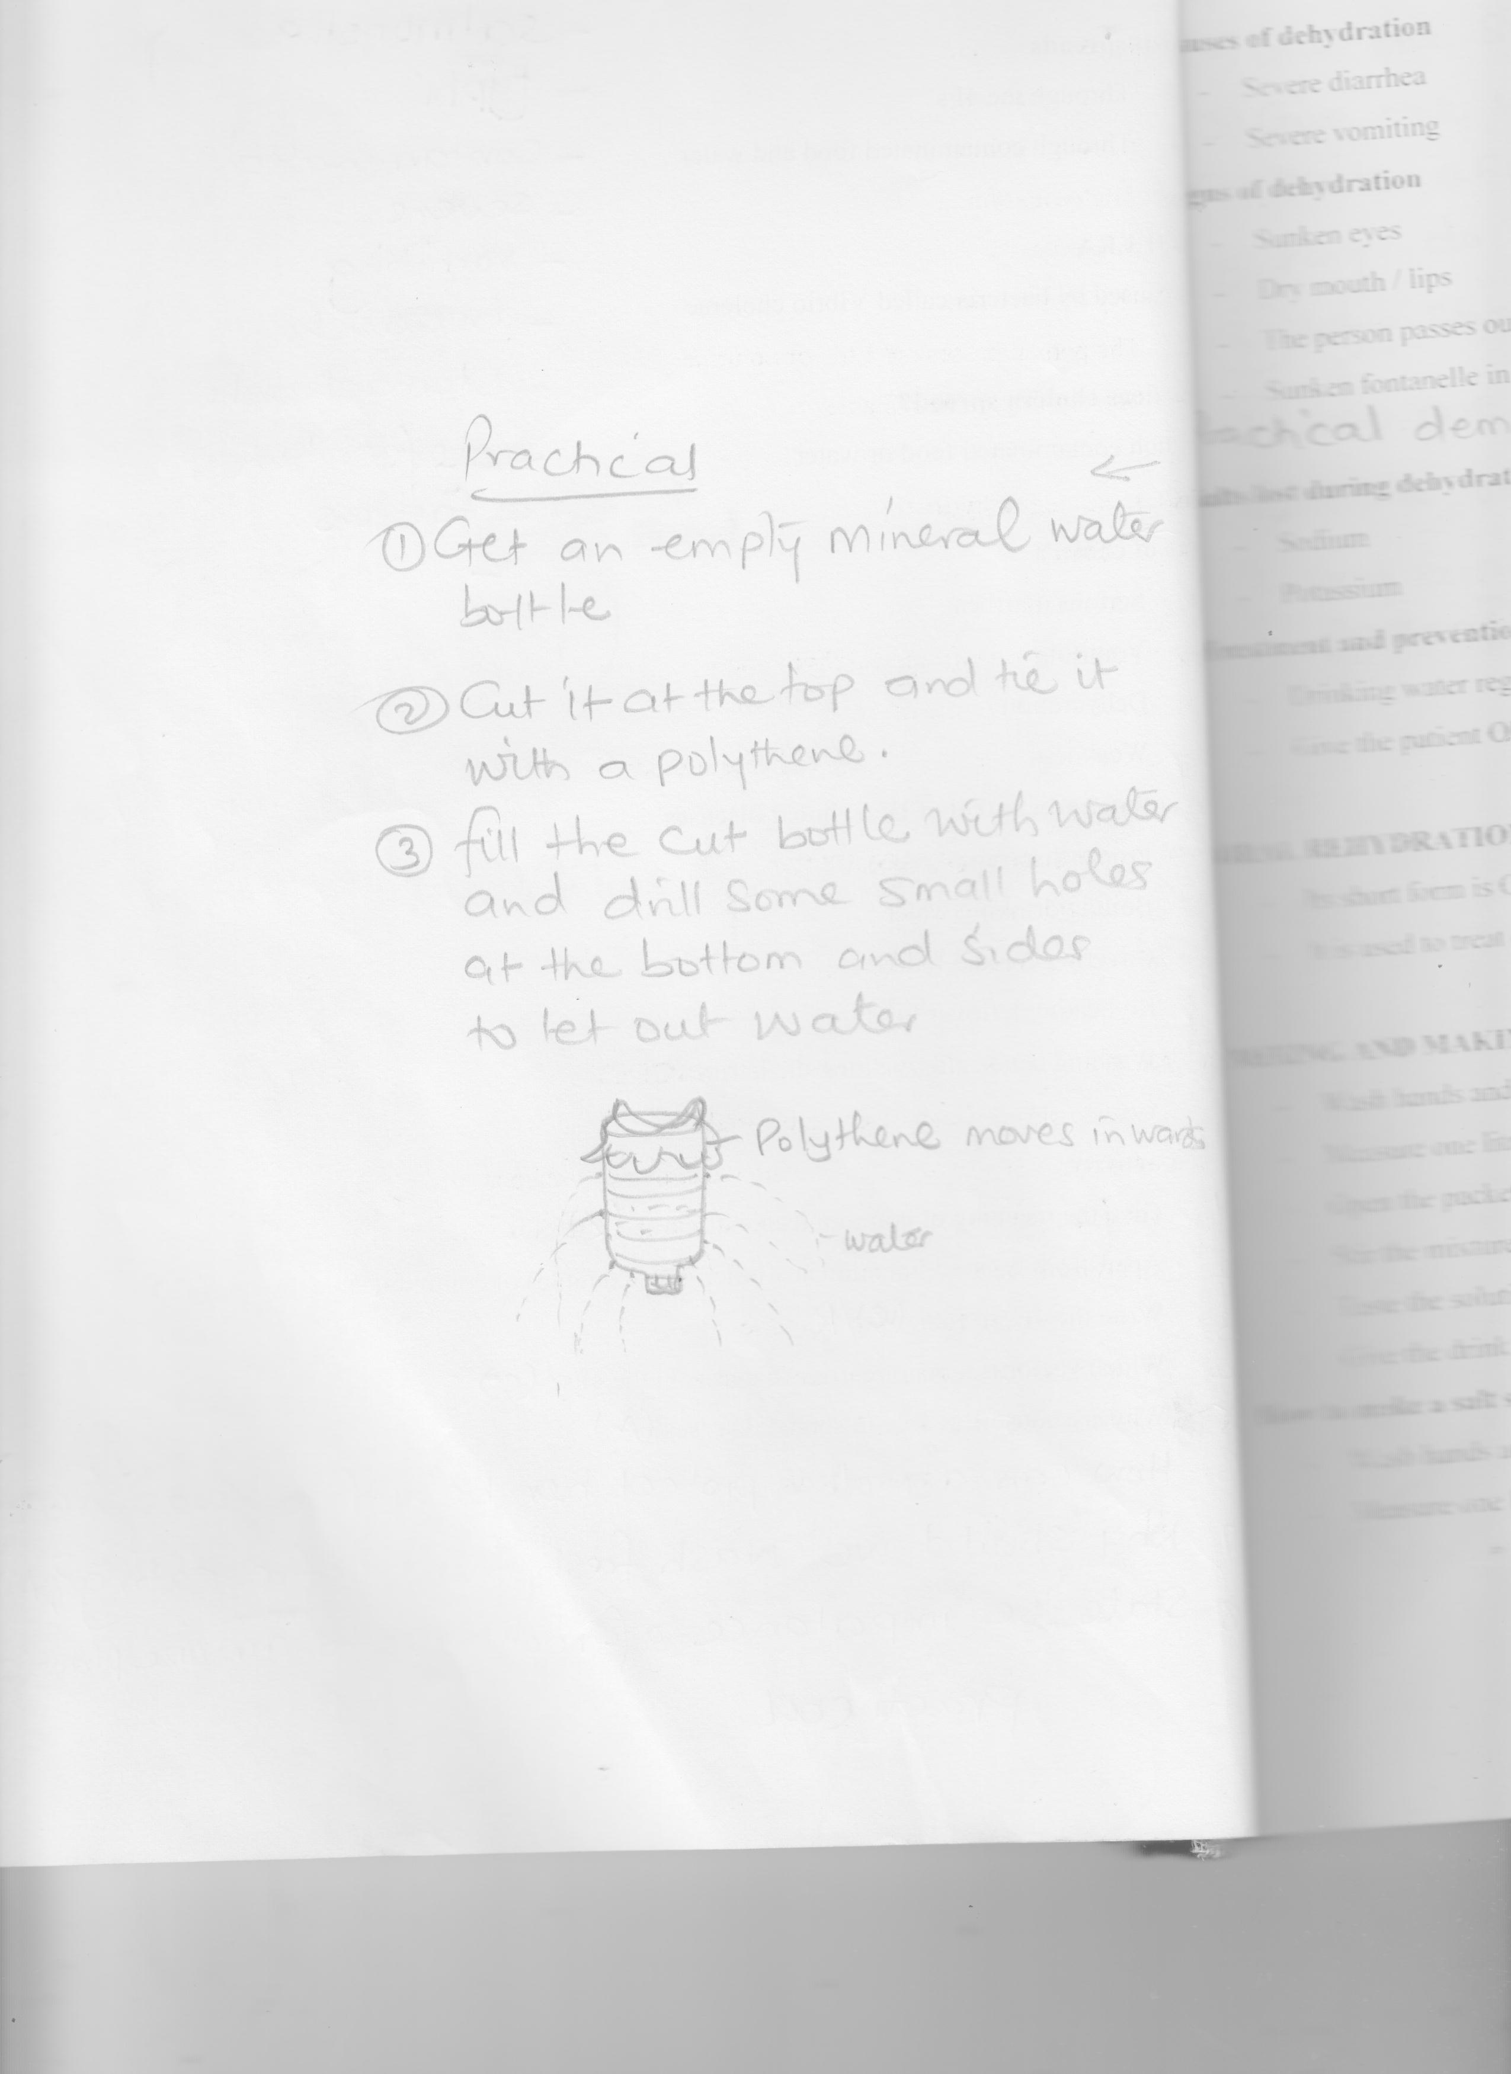

**Salts lost during dehydration**

* Sodium
* Potassium

**Treatment and prevention of dehydration**

* Drinking water regularly
* Give the patient ORS (Oral Rehydration Solution)

**ORAL REHYDRATION SOLUTION**

* Its short form is ORS .
* It is used to treat dehydration.

**MIXING AND MAKING ORS FROM A SACHET**

* Wash hands and containers to be used.
* Measure one litre of safe drinking water into a container.
* Open the packet of ORS and empty it into the litre of water.
* Stir the mixture well to form a solution
* Taste the solution, it shouldn’t taste salty
* Give the drink to the dehydrated person

**How to make a salt sugar solution locally**

* Wash hands and containers to be used
* Measure one litre of safe drinking water in to a container
* Measure one leveled teaspoon of salt and eight leveled tea spoons of sugar into a container of water.
* Stir the mixture well until the salt and sugar disappear.

**Mixed activity**

1. What is dehydration?
2. Give one sign to tell that Nakato is dehydrated.
3. Give one way food gets spoilt
4. Write 4Fs in full
5. Why do we keep our bodies clean?
6. Why should a dehydrated person be given ORS?
7. How are perennials different from annuals?
8. Name one garden crop pest.
9. How can oral fluids be useful to a dehydrated person?

**Note:**

* Taste the solution and ensure it is not salty
* Give the solution to a dehydrated person
* Sugar is used to give the patient energy.
* Salt is used to replace the lost salts (Sodium) in the body.

**Mixed activity**

1. Briefly explain the term dehydration.
2. Identify any two causes of dehydration.
3. How can P.4 children tell that one of their friends is dehydrated.
4. Why are victims of dehydration given ORS?
5. State the importance of salt during making of ORS.
6. Apart from sodium, name any other salt lost during diarrhea and vomiting.
7. Why should plants be pruned?

**WORMS**

**Vocabulary**

* Anaemia
* Infestation
* Parasite
* Hookworms
* Ascaris
* Round worms
* Swollen
* Belly
* Threadworms
* Sucker

WORMS

Worms are internal parasites.

A parasite is an organism that depends on another organism for food and shelter

**Examples of intestinal worms**

* Hook worms
* Thread worms / pin
* Tape worms
* Ascaris

**HOOK WORMS**

* They have hooks
* They live in the intestines
* They feed on blood in the human body.

**How they enter our bodies**

* By penetrating the skin when we walk bare footed in wet places
* When we drink water containing hook worms

**Danger of hook worms**

* They suck blood leading to hook worm anaemia

**Signs and symptoms of hook worm infestation**

* Abdominal discomfort
* The person feels weak and tired
* The person becomes anaemic
* Loss of weight

**Prevention of hook worms**

* Wash all fruits before eating
* Wearing sandles whenever going to a wet place.
* Boiling drinking water

**TAPE WORMS**

* They live in the intestines
* They feed on digested food
* Their bodies are divided into segment
* When the segment matures it breaks off
* They use hooks to hold onto the intestines

**How do tape worms enter our bodies**

When we eat half cooked meat containing tape worms

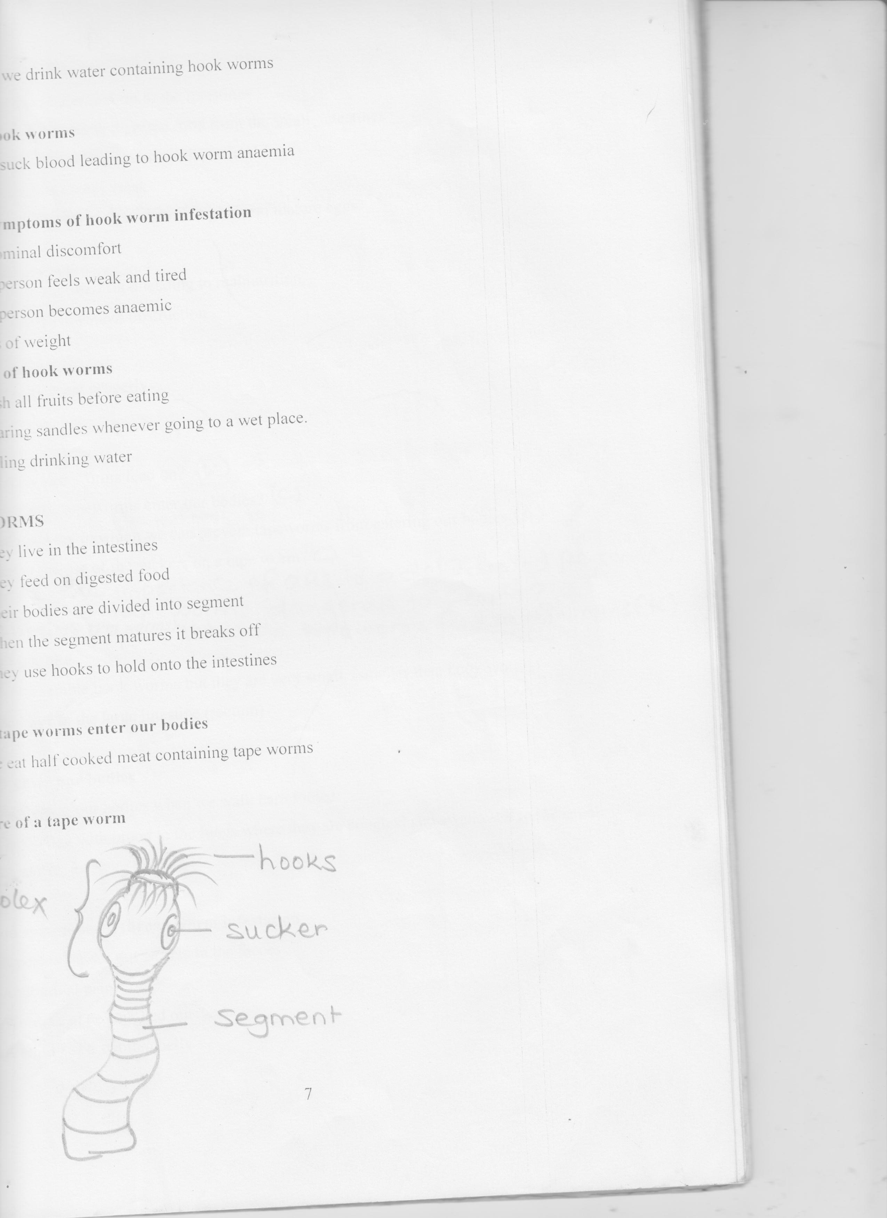**Structure of a tape worm**

**Scolex**

**Functions of the parts**

* **Hooks**  for attachment on to the intestines
* **Suckers**  for sucking digested food from the small intestines

**Signs and symptoms of tape worm infestation**

* The person becomes weak
* The person passes out stool with tape worm mature eggs.

**Dangers of tape worms**

* They suck digested food leading to malnutrition.
* They lead to intestinal obstruction

**Prevention on tape worms**

* Boiling all meat properly

**Activity**

1. What do tape worms feed on?
2. How do the tapeworms enter our bodies?
3. Give one way in which we can prevent tapeworms from entering our bodies.
4. What is the use of the suckers on a tape worm?
5. State the importance of ORS to a dehydrated person
6. How are tapeworms dangerous to people?
7. What do tape worms feed on in humans?

**THREAD WORMS (*Pin worms)***

**How they look like**

* They resemble hook worms but they are very small. (smaller than hook worms)
* They live in the large intestine (rectum)

**How they enter our bodies**

* They enter our bodies when we walk bare footed.
* They move with blood to the lungs where they are coughed and swallowed to the small intestines

**Signs and symptoms of thread worm infestation**

* A person passes out worms in the faeces
* Abdominal pain
* Worms can be coughed out
* A child has a swollen belly

**Prevention** **and control**

* Scrubbing toilet seats with soap
* Regular deworming
* Washing hands with soap after visiting the latrine.

**ASCARIS**

* They live in the bowels of man
* 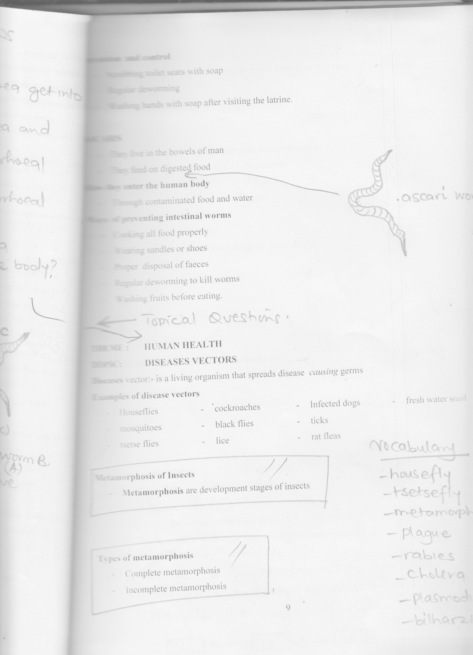They feed on digested food

Ascari worm

**How they enter the human body**

* Through contaminated food and water

**Ways of preventing intestinal worms**

* Cooking all food properly
* Wearing sandles or shoes
* Proper disposal of faeces
* Regular deworming to kill worms
* Washing fruits before eating.

**End of topic revision questions**

1. What is diarrhea ?
2. How do germs that causes diarrhea get into the body?
3. State the difference between diarrhea and dysentery.
4. State two ways of preventing diarrhoeal diseases.
5. How does a latrine help to control diarrhoeal diseases?
6. What do we call a condition when a person does not have enough water in the body?
7. State three signs of dehydration.
8. 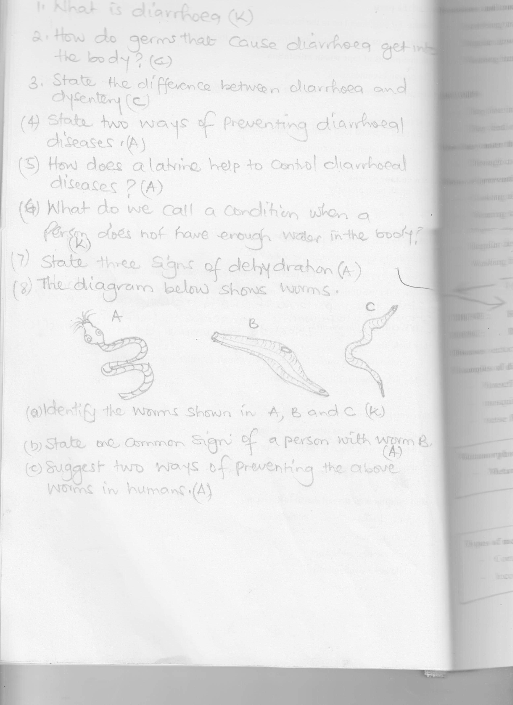The diagram below shows worms

1. Identify the worms shown in A, B and C.
2. State one common sign of a person with worm B
3. Suggest two ways of preventing the above worms in humans

**THEME : HUMAN HEALTH**

**Vocabulary**

* Housefly
* Tsetse fly
* Metamorphosis
* Plague
* Rabies
* Cholera
* Plasmodium
* Bilharzias

**HUMAN HEALTH**

**TOPIC: DISEASES VECTORS**

**Diseases** vector:- is a living organism that spreads disease  *causing* germs

**Examples of disease vectors**

* Houseflies
* mosquitoes
* tsetse flies
* cockroaches
* black flies
* lice
* Infected dogs
* ticks
* rat fleas
* fresh water snail

**Metamorphosis of Insects**

* **Metamorphosis** are development stages of insects

**Types of metamorphosis**

* Complete metamorphosis
* Incomplete metamorphosis

**Complete metamorphosis**

* Is the type of metamorphosis where an insect undergoes four stages of development.

**Stages of complete metamorphosis**

* eggs
* larva
* pupa
* adult

**Examples of insects which undergo complete metamorphosis**

* Houseflies
* Butterflies
* Bees
* Mosquitoes
* Wasps
* moths
* beetles
* ladybirds

**Incomplete metamorphosis**

This is where an insect undergoes three stages of development.

**Stages in incomplete metamorphosis**

* eggs
* nymph
* adult

**Insects that undergo incomplete metamorphosis**

* Grasshopper
* Locusts
* Termites
* cockroaches
* white ant
* bed bugs

**Activity**

1. Define the term vector
2. Differentiate between a vector and a germ
3. Mention one insect which under goes complete metamorphosis
4. Why is a housefly dangerous to man?
5. Apart from a grasshopper, name two other insects which undergo complete lifecycle.
6. Complete the stages of life cycle labeled A and B.

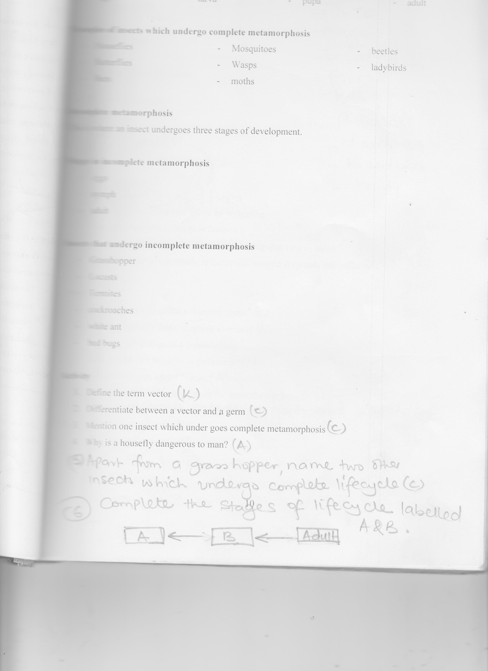

**CONTENT: HOUSE FLIES**

**Vocabulary**

* Rubbish
* Maggot
* Breeding
* Faeces
* Hairy
* Probascies
* Diarrhea
* Breeding
* Hairy

**HOUSE FLIES**

A house fly is a vector because it spreads many diseases.

It is able to spread diseases because it has the hairy body.

**Breeding places**

* Rotting rubbish
* Faeces
* Manure heaps
* Latrines
* Rotting bodies of animals

The lifecycle of a housefly

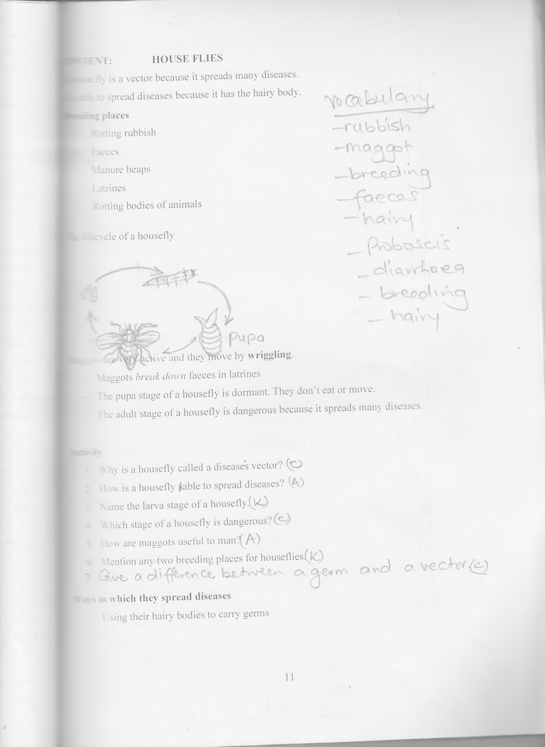

Maggots are very active and they move by **wriggling**.

* Maggots *break down* faeces in latrines
* The pupa stage of a housefly is dormant. They don’t eat or move.
* The adult stage of a housefly is dangerous because it spreads many diseases.

**Activity**

1. Why is a housefly called a diseases vector?
2. How is a housefly sable to spread diseases?
3. Name the larva stage of a housefly.
4. Which stage of a housefly is dangerous?
5. How are maggots useful to man?
6. Mention any two breeding places for houseflies.
7. Give a difference between a germ and a vector.

**Ways in which they spread diseases**

* Using their hairy bodies to carry germs

**The 4F’s germ path**

* Faeces
* Flies
* Food
* Fingers

**Diseases spread by a housefly.**

* Cholera
* Typhoid
* Trachoma
* Dysentery
* Diarrhoea

**Prevention of these faecal diseases**

* Cover leftover food.
* Throw away waste food
* Clean and cover latrines regularly
* Smoking pit latrines
* Burn rubbish
* Spray using insecticides
* Dispose faeces and urine in toilets properly

**Activity**

1. Mention three places where houseflies are found.
2. State two ways in which houseflies spread diseases.
3. Write the 4F’s in full and in order.
4. Mention two diseases spread by houseflies.
5. Point out two ways of preventing the diseases mentioned above.
6. Apart from a housefly, name any other disease vector.
7. Name the main vector in 4Fs germ path.
8. Why should we clean latrines regularly?

**MOSQUITOES**

**Vocabulary**

* Mosquito
* Trumpet
* Wriggler
* Proboscis
* Aedes
* Elephantiasis

**Types of Mosquitoes**

* Culex mosquito
* Anopheles mosquito
* Aedes/tiger mosquito

LIFE CYCLE OF MOSQUITOES

|  |
| --- |
| ANOPHELES CULEX AND AEDES |
| C:\Users\OFFICE\Pictures\2017-09-08\032.jpg |

* The larva stage of a mosquito is called a wriggler. The larva moves by wriggling in water.
* The active stages is larva stage and adult
* The dormant stage is pupa stage
* The dangerous stage is the adult stage because it spreads diseases.
* Culex mosquitoes spread *elephantiasis*
* The breeding areas of mosquito is stagnant water

**Activity**

1. Name the three types of mosquitoes.
2. What name is given to the larva stage of a mosquito?
3. Which stage of a mosquito is dangerous?
4. Write down one diseases spread by culex mosquitoes to humans.
5. Complete the table below

|  |  |  |
| --- | --- | --- |
| Mosquito | Disease | Germ |
| culex  anopheles  aedes/tiger | ______  ________  _______ | _______  _______  ________ |

1. Which germs cause malaria?

**Diseases spread by mosquitoes (mosquito borne diseases)**

* Malaria
* Elephantiasis
* Yellow fever

**Malaria**

* It is caused by plasmodia germs
* It is spread by infected female anopheles mosquitoes

**How it spreads**

* Malaria spreads through bites of infected female anopheles mosquitoes

**Signs and symptoms of malaria**

* Headache (symptom)
* Joint pain (symptom)
* Stomachache (symptom)
* Vomiting (sign)
* Body weakness (symptom)
* Fever(symptom)

**Elephantiasis**

* It is caused by filaria worms
* The disease is spread by a culex mosquito
* The disease makes the legs of the victim to swell like those of an elephant.

**Vocabulary**

* Filarial
* Yellow fever
* Elephantiasis
* Jaundice
* Stagnant
* Swollen feet

**Yellow fever**

* It is caused by a virus
* It is spread by an aedes / tiger mosquito.

**symptoms**

* headache
* backache

**Ways of controlling diseases spread by mosquitoes**

* Sleeping under treated mosquito nets
* Spraying using insecticides
* Slashing tall grass around homes
* Draining stagnant water
* Closing doors and windows in the evening
* Keeping fish in ponds to eat the mosquito larvae

**Activity**

1. What causes yellow fever?
2. Identify any two signs of a person with elephantiasis.
3. Name the diseases spread by these mosquitoes.
   1. Culex mosquitoes
   2. Aedes / tiger mosquito
4. Suggests three general ways of controlling diseases spread by mosquitoes.
5. Apart from culex and aedes, name one other types of mosquito.

**TSETSE FLIES**

**Vocabulary**

* Maggot
* Tsetse fly
* Hatches
* Bush
* Buries
* Insecticides
* Metamorphosis

**TSETSE FLIES**

* They spread sleeping sickness in man and nagana in farm animals.
* They feed on human and animal blood.
* They live in dark and shady places
* Tsetse flies do not lay eggs but they undergo four stages of development.
* The eggs hatch directly into larva in the female’s abdomen.

**LIFE CYCLE OF A TSETSE FLY**

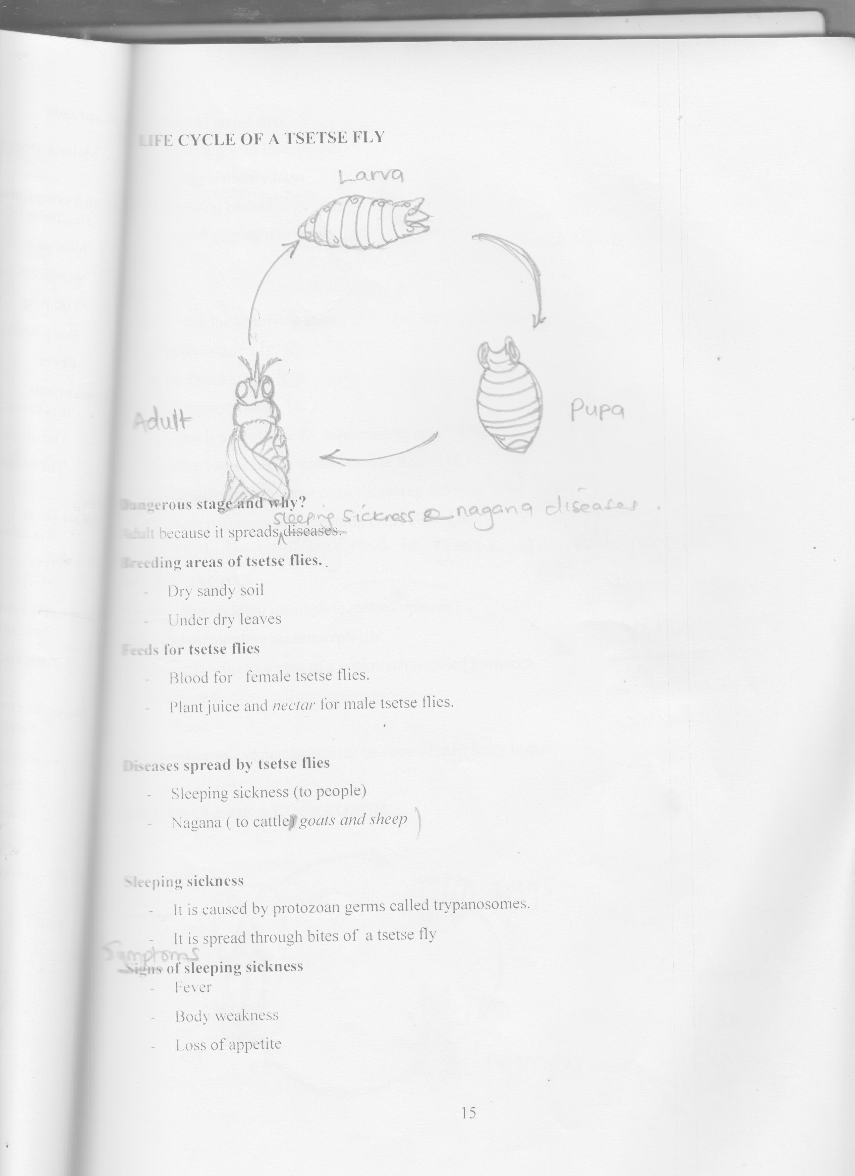

**Dangerous stage and why?**

Adult because it spreads sleeping sickness and nagana diseases.

**Breeding areas of tsetse flies.**

* Dry sandy soil
* Under dry leaves

**Feeds for tsetse flies**

* Blood for female tsetse flies.
* Plant juice and *nectar* for male tsetse flies.

**Diseases spread by tsetse flies**

* Sleeping sickness (to people)
* Nagana ( to cattle - *goats and sheep*

**Sleeping sickness**

* It is caused by protozoan germs called trypanosomes.
* It is spread through bites of a tsetse fly

**Symptoms of sleeping sickness**

* Fever
* Body weakness
* Loss of appetite

**Prevention of tsetse flies**

* Spraying with insecticides
* Using tsetse fly traps
* Clearing bushes
* Avoid grazing animals very early and late.

**Activity**

1. Name the following stages of development of a tsetse fly
2. active stage
3. Dormant stage
4. Dangerous stage
5. How is adult tsetse fly dangerous to man?
6. State two breeding areas of tsetse flies.
7. Identify the germ that causes sleeping sickness
8. State two ways of preventing tsetse flies.
9. Why is it dangerous to graze animals very early or late?

**COCKROACHES**

**Vocabulary**

* Cupboard
* Cracks
* Nymph
* Dysentery
* Typhoid
* Egg case
* Incomplete
* Dark
* Corners

Cockroaches undergo incomplete metamorphosis

**Stages of incomplete metamorphosis**

* Eggs - the egg case of a cockroach is called **oothecca**.
* Nymph
* Adult

Cockroaches spread many diseases because of their hairy bodies.

**LIFE CYCLE OF A COCKROACH**

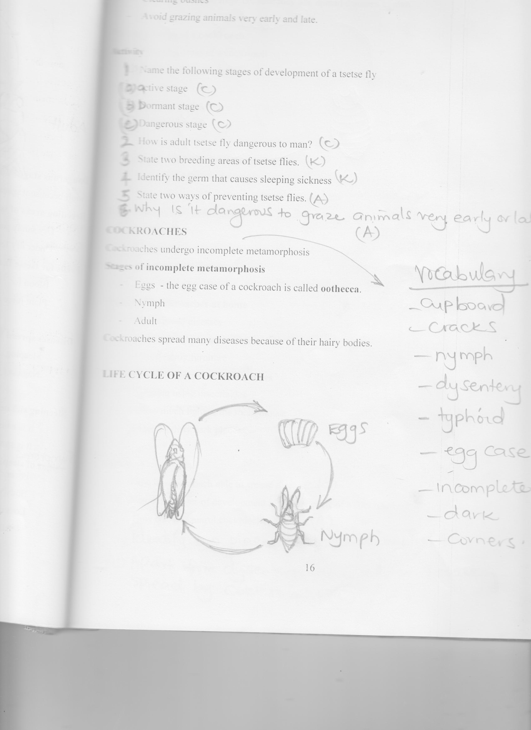

**Active** stage – nymph

**Dangerous** stage – adult stage because they *eat*  spread diseases to man

**Breeding areas of a cockroach**

* Breeding areas of a cockroach
* In the cupboards
* In boxes
* In books shelves
* In latrines

**Why do cockroaches move at night?**

* To look for food and water

**Diseases spread by cockroaches**

* Polio
* Dysentery
* Typhoid

**Dangers of cockroaches at home**

* They spread diseases
* They destroy papers and books
* They destroy furniture

**Prevention and control of cockroaches**

* Spraying using insecticides
* Allow much light in the room /house
* Clean all dirty dark places.

**Activity**

1. How is a cockroach able to spread disease?
2. Name the stages of development in the life cycle of a cockroach.
3. How can we control cockroaches at home.
4. Identify two places where cockroaches live.
5. Apart from dysentery, name another disease spread by cockroaches.

**RABID DOGS**

* Dogs are kept at home as pet animals

**Diseases spread by dogs.**

* Rabies is spread by infected dogs when they bite someone.

**Signs of rabies**

* A person becomes wild and mad.
* A person barks like a dog after 6 months

**Prevention and control**

* Vaccinate dogs
* Kill mad dogs
* Avoid playing with mad dogs

**TICKS**

* Ticks are commonly found on bodies of wild and domestic animals

**Feeds of ticks**

* Blood of man and animals

**Diseases spread**

* The ticks spread the germs that cause **relapsing fever**

**ITCH MITES**

* Itch mites spread a worm which lives and multiples inside our skins

**Diseases spread by itch mites**

* Scabies

**Signs of scabies**

* Itching and scratching on the skin

**FLEAS**

Fleas living on man bite him causing irritation, pain and scratching but don’t spread any disease.

The fleas that live on rats are called rat fleas.

* The diseases that is spread by rat fleas is called bubonic plague

**Signs of bubonic plague**

* Swelling in the neck, armpits and groin

**Prevention of bubonic plague**

* Kill the rat / poison the rats / trap them
* Spray with insecticides to kill fleas.
* People should take an anti – plague vaccination

**LICE**

**Types of lice**

* Body lice
* Hair lice
* Crab lice (found o pubic hair)

**Diseases spread by lice**

* Typhus fever

**Prevention of lice**

* Observe personal hygiene
* Cut off infected hair
* Use fine combs to remove the eggs and dead lice

**BEDBUGS**

* Bed bugs are not vectors
* They just suck blood from human beings
* Their bites lead to skin irritation

**Breeding places for bed bugs**

* Cracks of walls and floor
* Furniture
* Beddings
* The bed

**Dangers of bedbugs to man**

* Causes irritation

**Prevention of bedbugs**

* Pour hot water in beds to kill eggs
* Spray cracks of walls and floor with insecticides regularly
* Wash and iron beddings regularly

**Activity**

1. What do fleas found on rats spread?
2. Why do we pour hot water in beds?
3. Mention three types of lice
4. How is the habitat of a bed bug similar to that of a cockroach?

**Topical revision questions**

1. What is a vector?
2. Name atleast four common vectors and diseases they spread.
3. Which organ is attached by trachoma.

**Below is a summary of vectors with their diseases complete it carefully.**

|  |  |  |  |  |  |
| --- | --- | --- | --- | --- | --- |
| Name of Vectors | Body parts | Number of legs | Diseases | Cause | Control |
| Mosquito / culex | 3 | ______ | Elephantiasis | _____ | ______ |
| Anopheles | _____ | 6 | _____ | Plasmodium | _____ |
| Aedes | 3 | _____ | _____ | _____ | _____ |
| Cockroach | _____ | 6 | _____ | Shigella | _____ |
| Housefly | _____ | _____ | Diarrhoea | _____ | _____ |
| Tsetse fly | _____ | _____ | Diarrhea | _____ | Trypanosomes |
| Tick | _____ | 8 | Relapsing fever | _____ | _____ |
| Mites | 2 | _____ | _____ | _____ | _____ |
| Tsetse fly | _____ | _____ | Sleeping sickness | _____ | _____ |
| Fleas | 3 | 6 | _____ | _____ | _____ |
| Lice | _____ | _____ | Typhus fever | _____ | _____ |

**SUMMARY OF YOUNG ONES OF DIFFERENT VECTORS**

|  |  |
| --- | --- |
| **VECTOR** | **YOUNG ONE** |
| House fly | maggot |
| Cockroach | nymph |
| Tsetse fly | maggot |
| Mosquito | wriggler |

**THEME : HUMAN HEALTH**

**TOPIC : ACCIDENTS AND FIRST AID**

**Vocabulary**

* Choking
* Poisoning
* Vomiting
* Scald
* Injury
* Happening
* Zebra crossing
* Sudden
* Casualty

An accident is a sudden happening that causes harm to the body.

**Common accidents**

* choking
* drowning
* near drowning
* poisoning
* electricity shock
* animals bites
* fainting
* nose bleeding

**Causes of accidents**

* Burns – dry fire, heat like hot metal, hot charcoal, hot plate, hot saucepan.
* *Scald* – et heat like hot tea, hot porridge, hot milk, hot soup, steam
* Bites – snakes, dogs, cats
* Fainting – lack of enough supply of blood to the brain
* Drowning – lungs are full of water so they are unable to take in oxygen
* Shock – electricity

**Accidents at home**

* Nose bleeding
* Poisoning
* Near drowning
* Fainting
* Animal bites
* Burns and scalds

**Causes of accidents at home**

* Water in basins or big containers like buckets around the compound, swimming pools, pounds etc
* Playing dangerous games
* Careless keeping of objects
* Fighting
* Touching naked electric wires
* Playing with fire

**Accidents at school**

* Burns and scalds
* Fainting
* Electric shock
* Near drowning

**Causes of accidents at school**

* Playing with hot porridge and *tea*.
* Playing dangerous games
* Careless running
* Climbing walls and fences
* Playing with naked electric wires

**Accidents on roads**

* Animal bites
* Fainting
* Nose bleeding

**Causes of road accidents**

* Playing on roads
* Crossing the road carelessly
* Grazing animals on the roads
* Failure to follow road signs

**ROAD TRAFFIC ACCIDENTS**

These are accidents that happen to road users. e.g. drivers, passengers, pedestrians

**Pedestrians**:- are people who walk along the road.

**Drivers**:- are people who drive vehicles

**Passengers**:- people who are carried in vehicles.

**Causes of road traffic accidents**

* Driving vehicles at a higher speed.
* Driving vehicles which are not in good working condition.
* Driving over loaded vehicles.
* Failure to respect road signs.
* Abuse of high way traffic code by drivers.
* Crossing the road carelessly.
* Bad roads with potholes.
* Traffic jams
* Grazing animals along the road
* Driving while drunk.

**Prevention of road traffic accidents.**

* Control speed while driving.
* Avoid driving vehicles under dangerous mechanical condition
* Respect the road signs.
* Avoid driving while drunk.

**Crossing the road**

* First stop at the road
* Look right, look left, look right again
* If the road is safe cross quickly but don’t run because you may fall in the middle of the road.

**Activity**

1. Define the following:-
   1. Passengers
   2. Pedestrians
   3. motorist
   4. Road traffic accidents
2. Outline three causes of road traffic accidents
3. Mention three ways of controlling the accidents mentioned above.
4. Name any two colours of traffic lights.

**COMMON ROAD SIGNS**

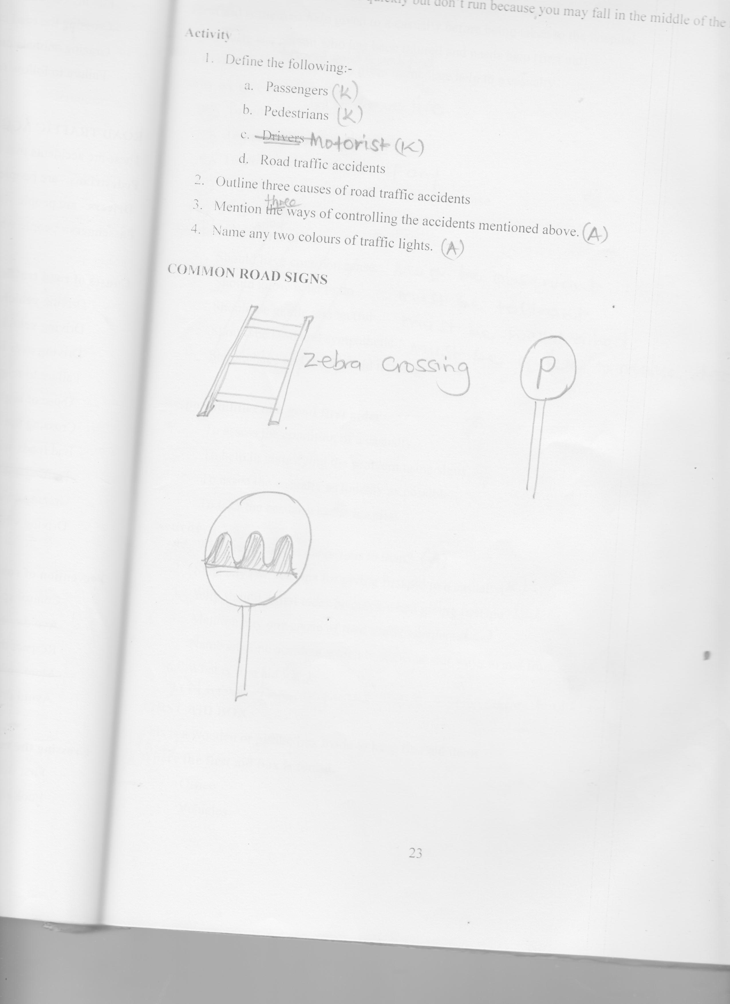

**FIRST AID**

**First aid** is the first *help* given to a casualty before being taken to the hospital.

**A casualty** is a person who has been injured and needs help (first aid)

**A first aider** is a trained and qualified person who gives immediate help to a casualty

**Why we give first aid**

1. To save life To reduce pain
2. To promote quick recovery
3. To stop or reduce bleeding if any
4. To prevent the condition from becoming worse
5. To give hope to a casualty

**Qualities of a good first aider**

* Must be observant
* Must be tolerant
* Must be well trained
* Must be quick to make decisions

**Responsibilities of a good first aider**

* To assess the condition of a casualty.
* To help in identifying the problem using signs.
* To assist the casualty as quickly as possible.
* To take the casualty to the hospital

**Activity**

1. Why are accidents dangerous to man?
2. State any two reasons for giving first aid to a casualty.
3. Why should a first aider be quick when giving first aid?
4. Mention any one cause of road traffic accidents.
5. Name any one accident which happens on our ways to and from school.
6. What is first aid?
7. Name two injuries that can affect us in life.

**FIRST AID BOX**

This is a wooden or plastic box made to keep first aid items.

**Places where the first aid box is found.**

* Office
* Vehicles
* Homes
* Clinics
* Hospitals
* Schools
* Red Cross centers.

A first aid box has shelves in it.

Its painted white with a red cross in the centre.

**TYPES OF CROSSES**

1. Faith cross 2. Health cross

**Illustration**

**Items in a first aid kit and their uses**

|  |  |  |
| --- | --- | --- |
| 1 | Cotton wool | * For cleaning wounds |
| 2 | Razor blade | * Cutting the plaster * Shaving hair from a wound |
| 3 | Pair of scissors | * Cutting a plaster bandage, gauze or a piece of cloth |
| 4 | bandage | * Holding fractured bones in position * Wrapping a sprained Joint |
| 5 | Safety pins | * For pinning a bandage |
| 6 | Adhesive plaster | * Covering small cuts or wounds |
| 7 | Iodine solution | * To clean wounds * To kill germs on wounds |
| 8 | Tweezers | * For picking up small objects from wounds * Used for holding cotton wool when cleaning the wound |
| 9 | Cotton gauze | * To protect wounds * To absorb fluids from scalds |
| 10 | Spirit | * Killing germs from wounds * Cleaning or disinfecting wounds |

**How to use first aid kit**

* Clean the hands with water and soap before touching them
* All drugs should be well labeled
* Never use dirty things or expired *drug*
* Use clean sterilized things

**Uses of first aid box**

* It helps to keep drugs and instruments safely
* Instrument and drugs are protected from sunlight and germs.

**Types of injuries / accidents**

* Fractures
* Burns and Scalds
* Dislocation
* Sprains and Strains
* Snake bites
* Insect stings

**Activity**

1. What is first aid?
2. Why are casualties always given first aid?
3. How is a first aid kit different from a first aid box?
4. In the space below, draw equipment used to clean wounds.
5. In which way is a zebra crossing useful to road users?

**FRACTURES**

**A fracture**:- s a broken or cracked bone.

**Types of fractures**

* Simple fracture
* Compound fracture
* Green stick fracture
* Comminuted fracture
* **Simple fracture**:- Is when a bone breaks and remains inside the skin.
* **Compound fracture**:- Is when the bone breaks and comes out of the skin. It pierces the flesh over laying the skin.
* **Greenstick fracture**;- Is when the bone doesn’t break completely, part of it remains attached. Its common in young children with soft growing bones.
* **Comminuted fracture**:- is when the bone breaks into many pieces.
* **Illustrations**

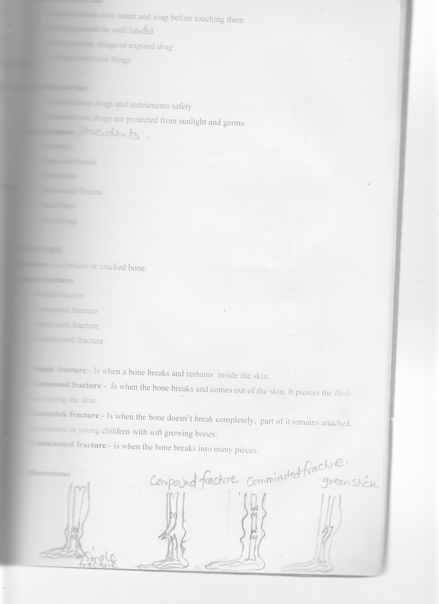

**Signs of fractures**

* The fractured part swells
* Inability to walk well

**Symptom**

* Feels pain

**First aid for fracture**

* Tie with splints to immobilize the broken bone.
* The splints can be made from pieces of wood o broken branches of trees.

***Why splints are used?***

If a casualty *can’t* walk , make a stretcher and take him or her to the hospital.

**Note**: Don’t attempt putting the bones back to their position for this can make the condition worse.

**SPRAIN, STRAIN AND DISLOCATION**

**Vocabulary**

* Injury
* Muscle
* Torn
* Over twisted
* Ligament
* Dislocation

**Symptom**

* Pain at the injured part.

**A sprain**:- Is a torn or stretched ligament.

**A strain**:- Is a torn or stretched muscles

**A dislocation**:- Is when a bone is displaced from its joint

**Signs of a sprain, strain and dislocation**

* Swelling around the injured part
* Pain at the point of injury
* Difficulty on moving the limb.

**First aid for sprain**

* Keep the joint in a resting position
* Wrap a piece of ice and apply on the sprained joint
* Tie the joint firmly with a bandage.

**POISONING**

**Poisoning**:- Is the state of eating or drinking things that harm our bodies or even cause death.

**Poison**:- Are the things that cause harm to our bodies or death when eaten or drunk.

**Examples of poison**

* paraffin
* Jik
* Rat poison
* Drugs (medicine)
* Expired foods

**Causes of poisoning**

* Eating or drinking drugs (medicine) in large amounts
* Keeping drugs carelessly where children can get them.
* Children tend to mistake poison to be soft drinks.

**Activity**

1. What is poisoning?
2. Define poison
3. Mention three things that may cause poisoning

**First aid for poisoning**

(paraffin, petrol, Jik or diesel)

* Give plenty of milk or water to drink

**Why do we give plenty of water or milk?**

* To dilute the poison
* The water or milk makes the poison harmless to the body

**Note**: Don’t let that person who has taken poison to vomit

Why?

* Vomiting causes more harm to a person

**Prevention of poisoning**

* Keep poison out of reach of children
* Avoid taking over dose
* Avoid eating expired packed food.
* Covering the mouth and nose when spraying insecticides

**Activity**

1. Name two ways of controlling poisoning by chemicals in a home
2. Give two ways of preventing snake bites.
3. How can insecticides be prevented from entering the nose and mouth when spraying?
4. Why is it dangerous to keep poison in soda bottles?
5. Mention one examples of poison.
6. Why do we give as person poisoned milk to drink?
7. Why should a poisoned victim not be forced to vomit?

**End of topic revision questions**

1. State some three causes of road and traffic accidents
2. Give the meaning of these colours of traffic light
   1. Red
   2. Orange
   3. Green
3. How is a zebra crossing important to road users?
4. Write down steps to follow before you cross the road.
5. Why are drugs kept out of children’s reach?
6. List down any three things in a first aid box.
7. What is the first aid for a simple cut?
8. Of what use are splints to fractured person?
9. Give a difference between a burn and a scald.
10. Cite one accident that can occur at school.

**Introduction**

* Ask learners to name common domestic animals, products, uses ….
* Tell learners about rabbit keeping as a project.

**RABBIT KEEPING**

**Rabbit keeping:-** is the rearing of domestic rabbits

* A male rabbit is called buck
* A female rabbit is called doe
* A group of young rabbits born together at the same time by a doe.
* A young rabbit is called a *kit*
* The meat of a rabbit is called rabbit meat.

**Why do we keep rabbits?**

* They provide us with meat
* They provide us with skins used to make hats, shoes, hand bags.
* Their droppings is *used* as manure
* They provide us with *fur*.

**Vocabulary**

* Hutch
* Morrant
* Doe
* Kit
* Litter
* Whister
* Fur
* Pneumonia
* Ear canker
* Snuffles

**THE STRUCTURE OF A RABBIT**

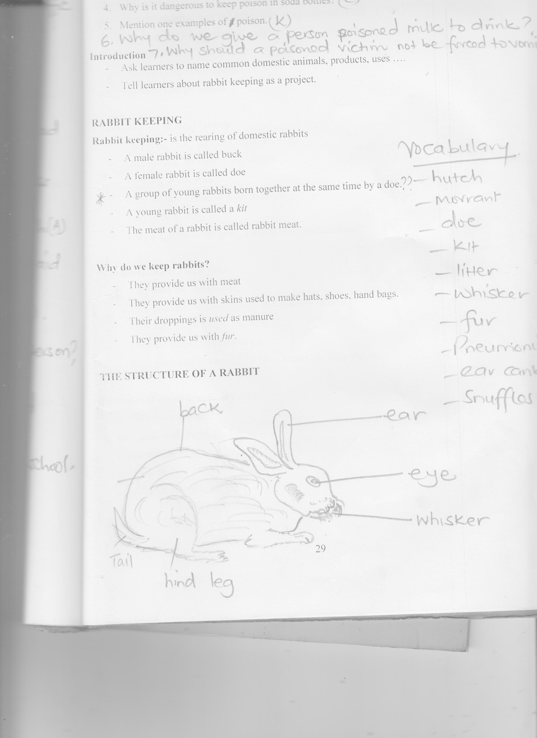

**ADVANTAGES OF KEEPING RABBITS**

* They feed on many things which other animals don’t feed on.
* They produce quickly than other animals.
* They need very small space for keeping them unlike other animals
* They produce high soft quality meat than other animals two points
* They are cheap to buy and keep than other animals
* Mature quickly than other animals.

**Breeds of rabbits**

* Local or indigenous rabbits
* Exotic or foreign rabbits

**Characteristics of local rabbits**

* They have many different colours
* They are smaller than exotic rabbits
* They live in the bush
* They are just hunted in order to be go
* They grow slowly
* They dig holes in the ground where they produce from

**Characteristics of exotic rabbits**

* They have the same colour
* They produce the same quality and quantity of meat
* They have same weight and size
* They are simple and easy to get
* They produce you ones of the same habits like their parents.

**Examples of exotic breeds of rabbits**

* Newzealand white
* California rabbits
* chinchilla rabbits
* Earlops
* Angora rabbits

**HOW THE EXOTIC RABBITS LOOK LIKE**

**Newzealand white rabbits**

* They are white.
* They have short legs
* They produce a lot of meat
* They have pink eyes
* They can reach 5kgs when mature

**California rabbits**

* White in colour, the tail nose and feet are black or dark brown.
* They grow faster than other rabbits
* They weigh 5kg when mature.

**Chinchilla rabbits**

* They are grey in colour
* They are lighter compared to Californian
* They are *used* for upgrading local rabbits

**Angora rabbits**

* They are white in colour
* They produce fine silky hair
* They produce good quality meat

**Earlops**

* They are bigger then other rabbits
* They weigh 6kgs when mature
* Their ears drop on the side of the head
* They grow slowly.

**Selecting good rabbits to rear**

* Select healthy rabbits with shiny coat, bright eyes a dry clean nose and without any discharge from the eyes.
* Select a rabbit that is well covered with hair and well shaped.
* Select rabbits that are big in size.

**HOUSING OR RABBITS**

A house of rabbits is called a pen or hutch.

It should be kept clean and dry protected from wind, sunshine and enemies

Hutches or pens should be raised off the ground to protect them from dogs

**Rabbitary**:- Is the keeping of rabbits in many hutches in one place.

**Type of rabbit hutches**

* Modern cages – water
* Wire mesh cages
* *Amorrant* (moved from one place to another to allow than feed on grass)

***Diagram of a morrant rabbit***

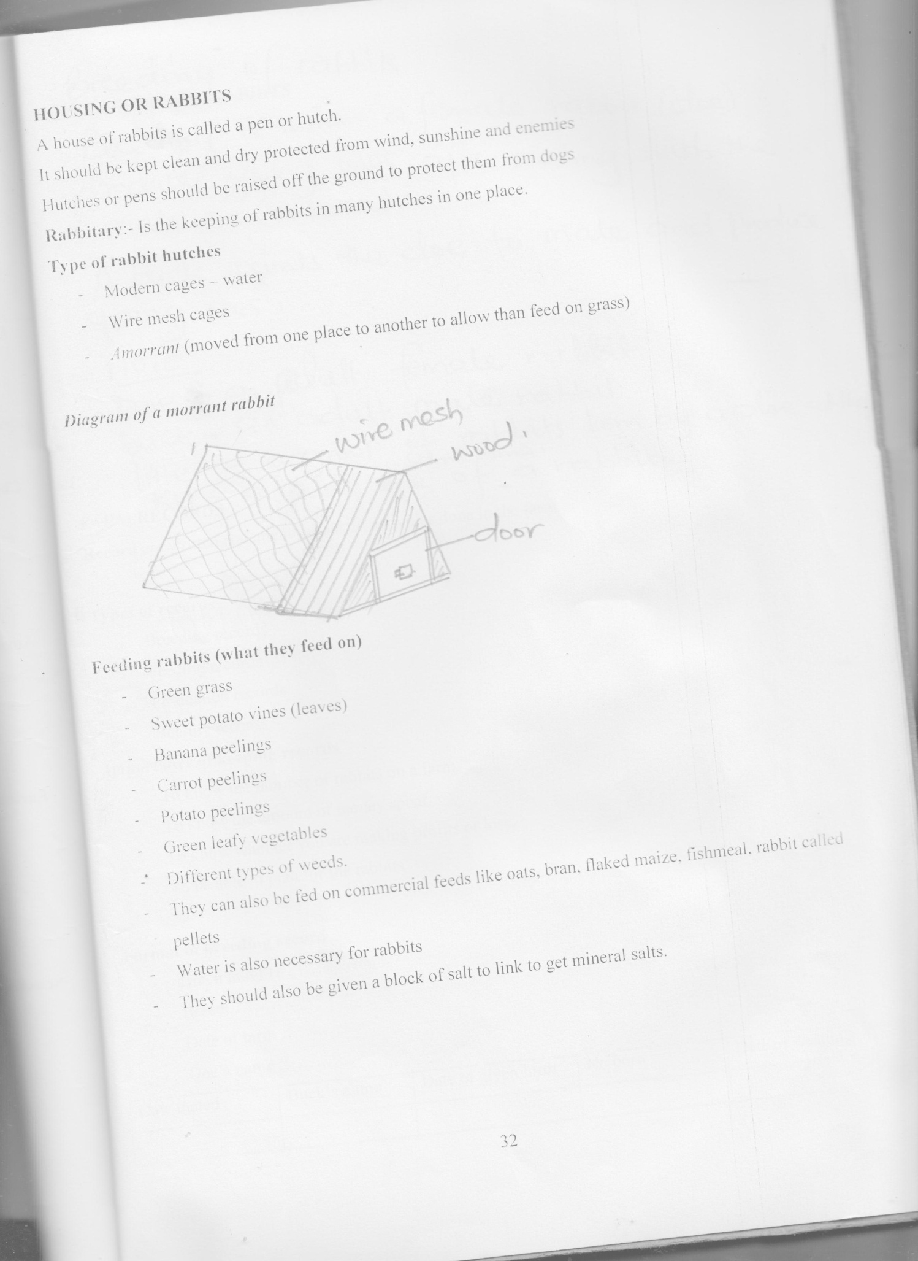

**Feeding rabbits (what they feed on)**

* Green grass
* Sweet potato vines (leaves)
* Banana peelings
* Carrot peelings
* Potato peelings
* Green leafy vegetables
* Different types of weeds.
* They can also be fed on commercial feeds like oats, bran, flaked maize, fishmeal, rabbit called pellets
* Water is also necessary for rabbits
* They should also be given a block of salt to link to get mineral salts.

**Breeding of rabbits**

Breeding is when a female rabbit (doe) produces young ones after mating with the make one (a buck)

A buck mounts the doe to mate and produce young ones.

**Note**

Doe- an adult female rabbit

Buck – an adult male rabbit

Litter – a group of rabbits born by a doe at the same time.

Kit – a young one of a rabbit.

**FARM RECORDS**

**Record** are written statements about all activities done in the farm.

**Types of records**

* Breeding records
* Feeding records
* Production records
* Healthy records

**Importance of keeping records**

* To know the number of rabbits on a farm.
* To know the amount of money spent.
* To know whether you are making profits or loss.
* To be able to plan for the rabbits

**Format of breeding record**

* Hutch number …………
* Breed …………
* Date of birth …………
* Doe’s name ………….

|  |  |  |  |  |
| --- | --- | --- | --- | --- |
| Date mated | Buck’s name | Date of given birth | No born | Date of weaning |
|  |  |  |  |  |

**Signs of health rabbits**

* They are bright and observant
* They are smooth and have shinny hair
* They have clean nose
* They are quick in movement and alert
* Their dung is in form of firm pellet

**Common diseases of rabbits**

* Coccidiosis
* Ear canker
* Sours
* Colds
* Pneumonia

**DISEASES OF RABBITS**

* Coccidiosis
* Pneumonia
* Ear canker
* Colds
* Sours
* **Pneumonia** is common to people
* **Coccidiosis** is common to poultry

**Signs and symptoms of coccidiosis**

* A rabbit develops diarrhoea with blood
* A rabbit has swollen stomach
* Rabbits become small and thins
* They have rough hair

**Prevention of coccidiosis**

* Keep the hutch clean
* Feed with clean water and feeds
* Put drugs in clean drinking water

**Signs and symptoms of sours**

* The rabbit stops feeding.
* Pain in the stomach
* Diarrhoea

**Prevention of sours**

* Don’t give rabbits young and wet greens and grass
* Clean the hutches and spray regularly.

**Ear canker (signs and symptoms)**

* The rabbits itch and scratch their ears.
* The ears develop wounds and discharge and become painful.

**Prevention of ear canker**

* Pour paraffin on cotton and clean the ears regularly.
* Avoid overcrowding the rabbits in one hutch.

**Signs and symptoms of pneumonia**

* Rabbits start shivering
* Difficulty in breathing
* Lack of appetite
* High temperatures

**Prevention of pneumonia**

* Keep the hutches dry and clean.
* Avoid rain into the hutches.
* Treat with drugs

**Signs of colds**

* Water discharge from the nose and sneezing

**Prevention of diseases in rabbits**

* Keep the hutches clean.
* Avoid rain into the hutches.
* Keep sick rabbits away from normal ones.
* feed rabbits well with greens
* Avoid overcrowding rabbits
* Call a veterinary doctor to check on their health

**End of topic revision questions**

1. Name four external parts of a rabbit
2. Write down two uses of rabbits to people
3. Name the type of rabbits to people
4. Name the type of rabbits that mature faster
5. Match items in A with their correct answers in B.

|  |  |
| --- | --- |
| **A** | **B** |
| Doe  Buck  Litter  Breeding | Mating of a buck with a doe to produce young ones  Young rabbit  Male rabbit  Female rabbit |

1. Why do we keep rabbits in a clean hutch?
2. Write down the common sign of a disease and pest on rabbits.
3. Why do we keep rabbit records?
4. Which way can we control diseases and parasites in rabbits.
5. Name one rabbit feed.